Fundamental of data science
Lab experiment 1 to 6

- Student Performance Analysis

import numpy as np

student_scores = np.array([
[80, 75, 90, 85],
[70, 80, 85, 75],
[90, 85, 80, 90],
[85, 90, 95, 80]
])

subjects = ["Math", "Science", "English", "History"]

# Calculate average for each subject
averages = np.mean(student_scores, axis=0)

print("Average scores:")
for i in range(4):
print(subjects[i], ":", averages[i])

# Find subject with highest average
highest_index = np.argmax(averages)

print("Subject with highest average:", subjects[highest_index])
print("Highest average:", averages[highest_index])

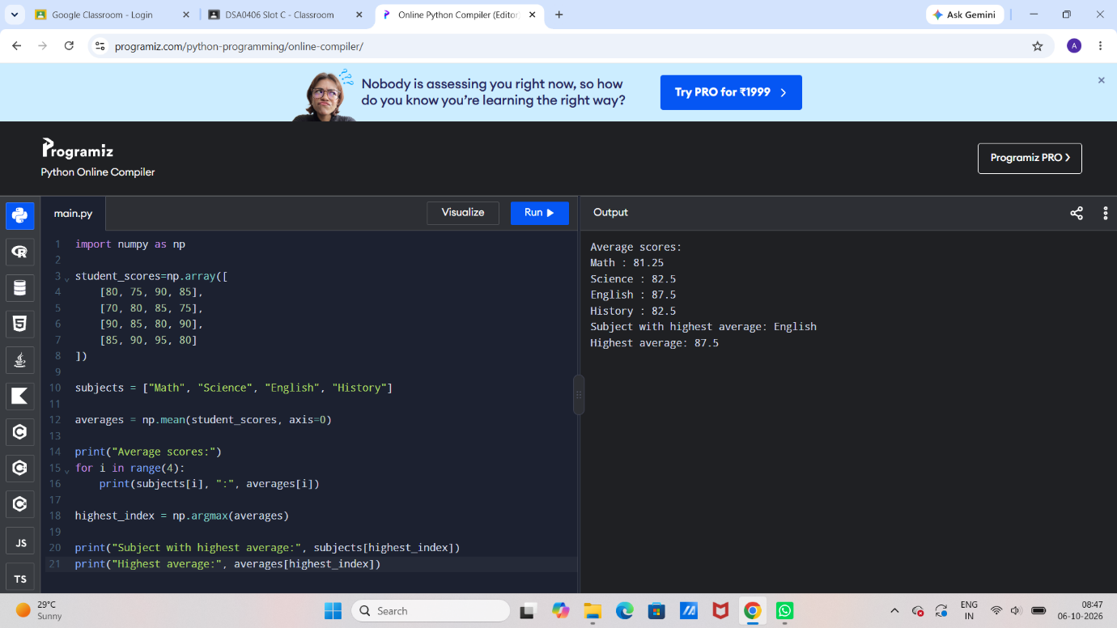

2. Average Sales Price Calculation

import numpy as np

sales_data = np.array([
[100, 200, 150],
[250, 300, 350],
[120, 180, 200]
])

average_price = np.mean(sales_data)

print("Average price:", average_price)

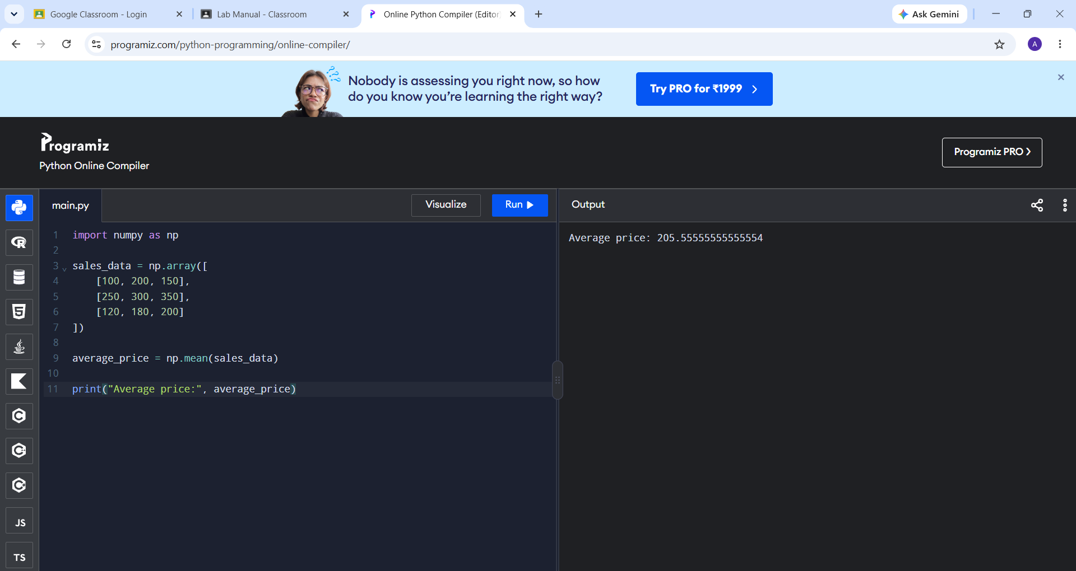
3.House Price Analysis

import numpy as np

house_data = np.array([
[3, 1500, 300000],
[5, 2200, 500000],
[6, 2500, 600000],
[4, 1800, 400000],
[7, 3000, 700000]
])

# Select houses with more than 4 bedrooms
houses = house_data[house_data[:, 0] > 4]

# Get the sale prices
prices = houses[:, 2]

# Calculate average sale price
average_price = np.mean(prices)

print("Average sale price:", average_price)

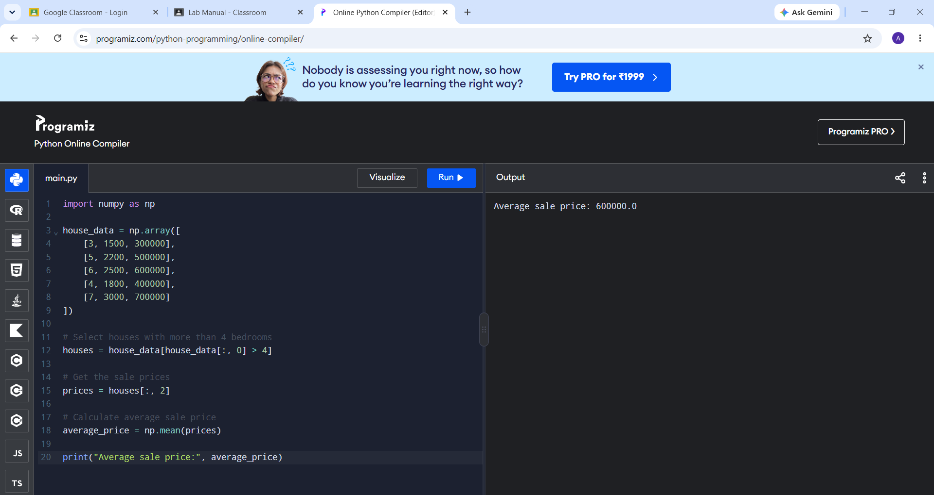

4. Quarterly Sales Analysis

import numpy as np

sales_data = np.array([10000, 12000, 15000, 18000])

# Calculate total sales
total_sales = np.sum(sales_data)

# Calculate percentage increase from Q1 to Q4
percentage_increase = ((sales_data[3] - sales_data[0]) / sales_data[0]) * 100

print("Total sales for the year:", total_sales)
print("Percentage increase:", percentage_increase, "%")

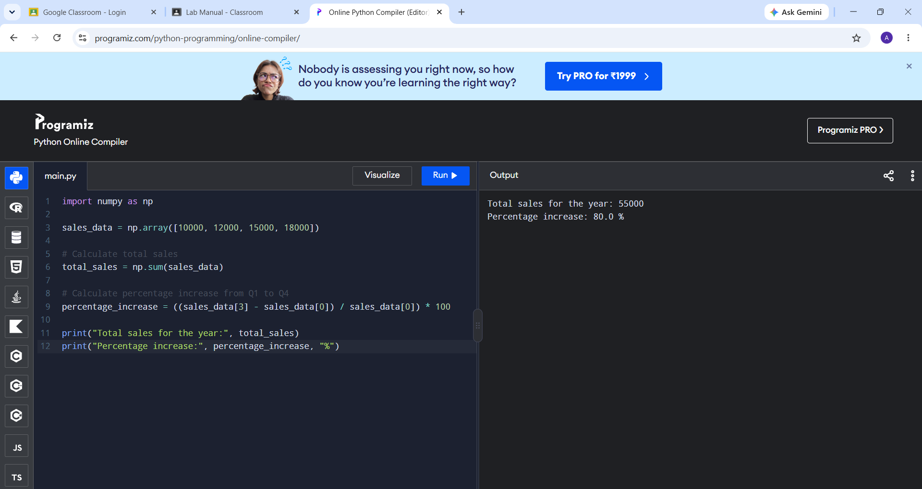

5. Fuel Efficiency Analysis

import numpy as np

fuel_efficiency = np.array([25, 30, 35, 40])

# Calculate average fuel efficiency
average = np.mean(fuel_efficiency)

# Calculate percentage improvement from first car to second car
percentage_improvement = ((fuel_efficiency[1] - fuel_efficiency[0]) / fuel_efficiency[0]) * 100

print("Average fuel efficiency:", average)
print("Percentage improvement:", percentage_improvement, "%")

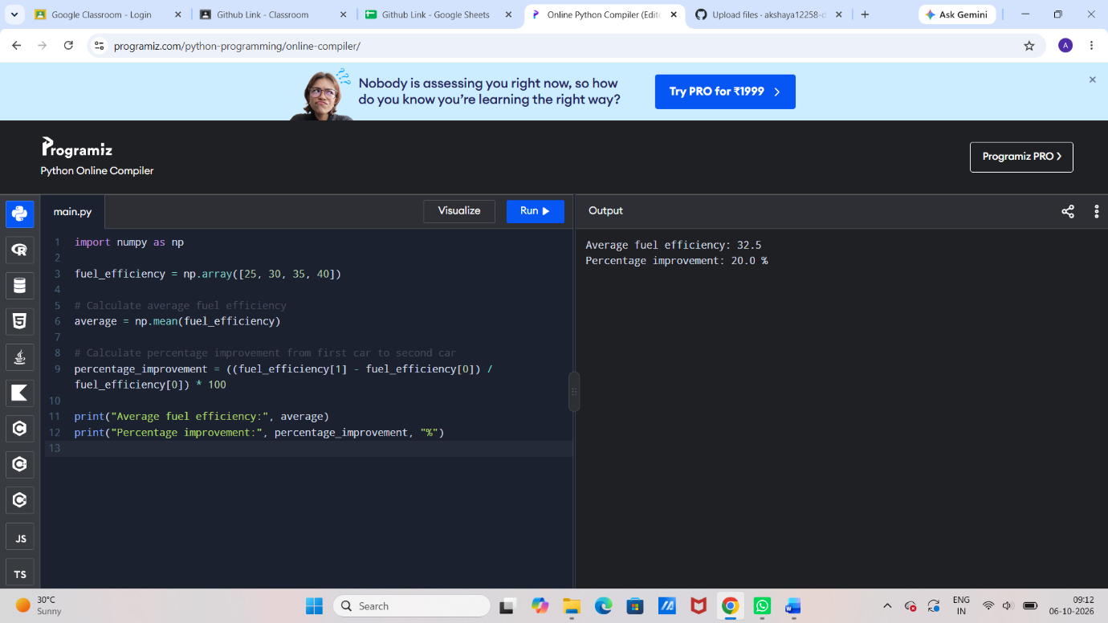

6. Grocery Store Total Cost Calculation

item_prices = [100, 200, 50]
quantities = [2, 1, 3]

discount_rate = 10
tax_rate = 5

# Calculate subtotal
subtotal = sum(price * quantity for price, quantity in zip(item_prices, quantities))

# Calculate discount
discount = subtotal * discount_rate / 100

# Price after discount
price_after_discount = subtotal - discount

# Calculate tax
tax = price_after_discount * tax_rate / 100

# Final total
total_cost = price_after_discount + tax

print("Subtotal:", subtotal)
print("Discount:", discount)
print("Tax:", tax)
print("Total cost:", total_cost)

